Data Mining

0753428高碩輿

RNN(有Dropout)🡪 Accuracy: 0.7135

RNN(無Dropout)🡪 Accuracy: 0.388888892200258

LSTM(有Dropout)🡪 Accuracy: 0.7189

LSTM(無Dropout)🡪 Accuracy: 0.7426

結論: 使用LSTM較準確，有Dropout也較準

**RNN(有Dropout):**

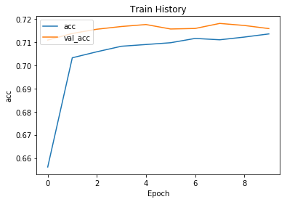

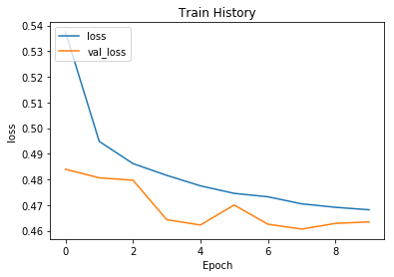

**RNN(無Dropout):**

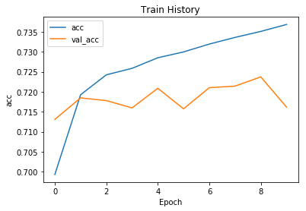

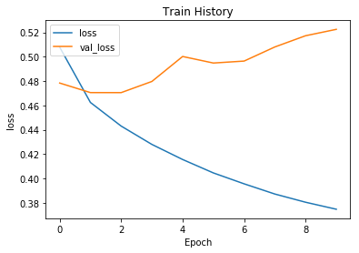

**LSTM(有Dropout):**

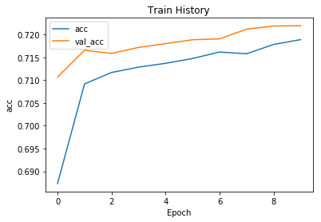

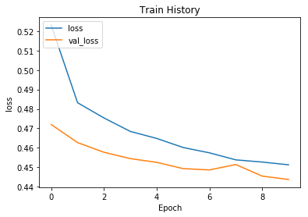

**LSTM(無Dropout):**

